BHARAT SHIKSHAN PRASARAK MANDAL
RASHTRAPITA MAHATMA GANDHI ARTS COMMERCE & SCIENCE COLLEGE SAOL
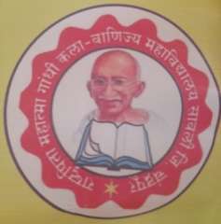
Department of Library and Information Science

Session – 2024 -25
Report on – Library Awareness Program

Submitted by
Prof. Dilip Sontakke ( Librarian )

- Library Awareness Program
On dated 5th August 2024, Tuesday Library Awareness Program was conducted in the beginning of the college, so that the new comer students of the college will be aware about the library department. The intention of the program was , how to register in the library , which services and systems are given in the library and what is the books collection besides Newspapers, Journals , Reference books , Online databases, Internet services, Xerox services. Newspaper clippings. In this way we tried to make aware to the new comer students by this activity.

