RASHTRAPITA MAHATMA GANDHI ARTS, COMMERCE AND SCIENCE COLLEGE, SAOLI
VISIT TO
CENTRAL INSTITUTE OF PETROCHEMICAL ENGINEERING AND TECHNOLOGY (CIPET) CHANDRAPUR

ONE DAY TRAINING PROGRAM ON “PLASTIC MATERIALS AND MODERN PLASTIC PROCESSING TECHNIQUIS”

REPORT ON VISIT TO CENTRAL INSTITUTE OF PETROCHEMICAL ENGINEERING AND TECHNOLOGY (CIPET) CHANDRAPUR

The department of physics in collaboration with chemistry organized a visit on 22/2/22 to centre for skilling and technical support department of chemicals and petrochemical, Chandrapur. The two departments of Rashtrapita Mahatma Gandhi Arts, Commerce and Science College, Saoli jointly signed the memorandum of understanding (MOU) with Central Institute of Petrochemical Engineering and Technology (CIPET) Chandrapur.
The objective of the MOU is to provide skill based inplant trainings, incubation, and education and research related cooperation and other supporting services. There were 40 students in the visit along with the two faculty members Dr. Prerna R. Modak head department of Physics and Mr. Sandeep Deshmukh head department of Chemistry.
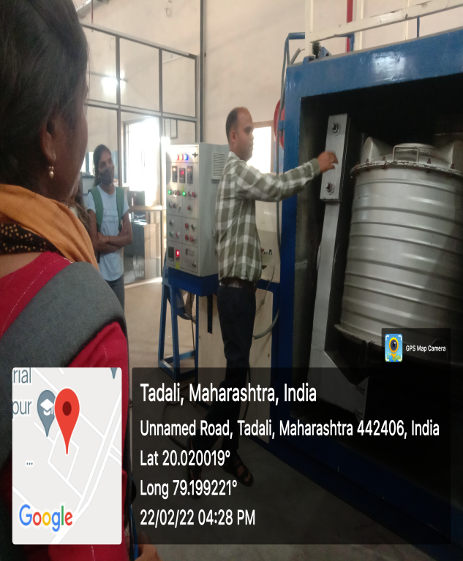
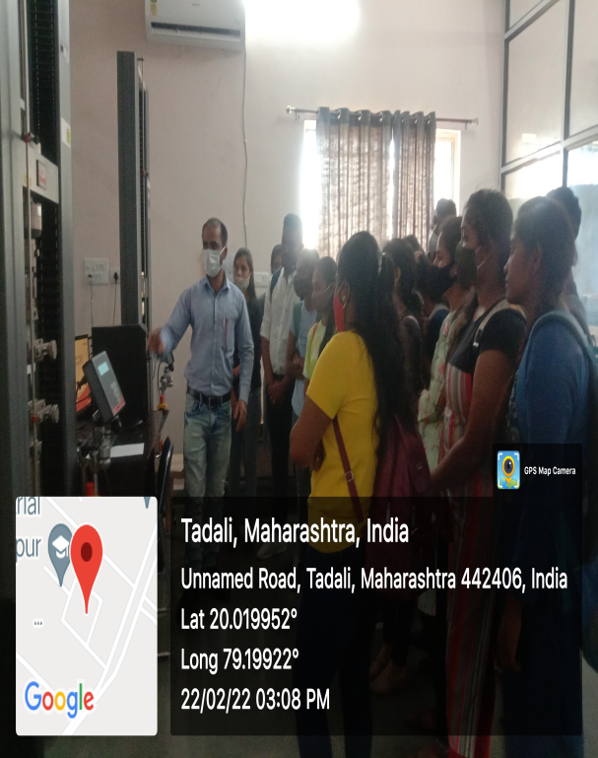
The schedule was planned to visit characterization laboratory, tools laboratory, testing laboratory and processing laboratory. The visit was divided in two sessions, in the first session, which was the theoretical session was conducted by Mr. Sharth P.T. In his lecture he gave a brief introduction about plastic processing techniques and plastic materials and Mr. Naved Siraj explained the various testing tools for plastic materials. The second session was the practical session, Mr. Parasram Nikam and Gokul Kurwale explained the working of various instruments used for testing and processing of plastic materials. The students mesmerize with practical sessions and the processing of the plastic objects they prepared in the laboratory.
