Bharat Shikshan Prasarak Mandal’s
Rashtrapita Mahatma Gandhi Arts, Commerce & Science College, Saoli Dist. Chandrapur (M.S.)
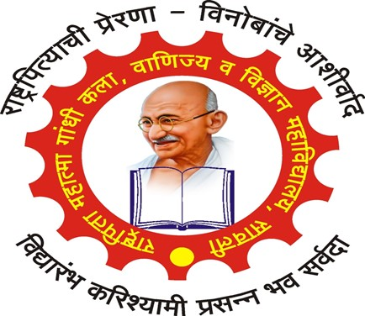
Affiliated to Gondwana University, Gadchiroli

Report on
“Workshop on Entrepreneurship”
12th April 2023

Submitted By
Department of Commerce

On April 12, 2023, a one-day workshop on "Entrepreneurship" was organized at Rashtrapita Mahatma Gandhi Arts, Commerce & Science College Saoli, which is a part of the College's academic activities. The workshop was held under the leadership of Dr. Ashok Khobragade, the Principal of College, and was inaugurated by Dr. Kshama Gavai, Assistant professor of Janata Mahavidyalaya, Chandrapur. During this workshop, participants learned how to prepare a business plan and were actively engaged in practical activities on candles making. The workshop encouraged active participation from all the students. Dr. Ashok Khobragade, the Chairman of the workshop, also provided guidance to the students regarding entrepreneurship and finance. This workshop aimed to inspire students to pursue entrepreneurship and business ventures. The proposal for this workshop was put forth by Dr. Vinod Badwaik, the Head of the Commerce Department. The successful execution of this workshop was made possible through the collective efforts of professors like Dr. Prashant Vairale, Prof. Saghnanad Bagde, Prof. Sadip Deshmukh, Prof. Mahananda Bhakare, and others from various departments. All the students from the Commerce department actively participated in this workshop.
The success of this workshop was attributed to the dedication and hard work of both the professors and the students.

